OPERATING SYSTEMS
− Seminar 7 −

FILE SYSTEMS IN LINUX

1. BASIC CONCEPTS
- a file system controls how data is stored on and retrieved from a storage medium
- file system concepts: partition, file, directory, path
- storage mediums: magnetic tape, floppy disk, hard disk, optical disk, SSD (Solid State Drive)
- storing data on disks: track, sector, disk block
- file systems:
  - for disks: FAT (FAT12/FAT16/FAT32), NTFS, exFAT, HFS, HPFS, APFS, ext2fs, ext3fs, ext4fs, ReiserFS, XFS, ZFS etc.
  - for optical disk: ISO 9660, UDF (Universal Disk Format)

2. JOURNALING FILE SYSTEMS
- issues in classic file systems:
  - the consistency of file system is affected by failures (i.e. system crashes, software crashes, improper shutdowns, power outages)
  - following a crash the fsck (file system consistency check) utility has to be run
  - fsck will scan the entire file system validating all entries and making sure that blocks are allocated and referenced correctly; if it finds a corrupt entry it will attempt to fix the problem
- solution: fault-resilient file systems
- the first fault-resilient file system was the IBM Journaled File System (JFS)
- it was first released in 1990 by IBM Corp. for its AIX operating system
- a journaling file system = a file system that maintains a special file called a "journal" that is used to repair any inconsistencies that occur as the result of a failure
- a journaling file system records changes to the file system; in this way it is able to recover after a failure with minimal loss of data
- a journaling file system write metadata (i.e. data about files and directories) into the journal that is flushed to the disk before each command returns
- examples:
  - Windows: NTFS (New Technology File System)
  - Unix/Linux: ext3fs (third extended file system), ext4fs, ReiserFS, JFS/JFS2, XFS etc.
- the most common journaling strategies:
  - writeback mode - only the metadata is journaled, and the data blocks are written directly to their location on the disk
  - ordered mode - metadata journaling only, but writes the data before journaling the metadata
  - data mode - both metadata and data are journaled
- advantage: the structure of the file system is always internally consistent
- drawbacks: journaling does not give a performance boost; in fact, the journaling operation reduces the speed slightly, in exchange for reliability

3. FILE SYSTEMS IN LINUX
- Linux supports almost 100 types of file systems
- in Linux and many other operating systems, directories can be structured in a tree-like hierarchy; the Linux directory structure is well defined and documented in the Linux Filesystem Hierarchy Standard (FHS)
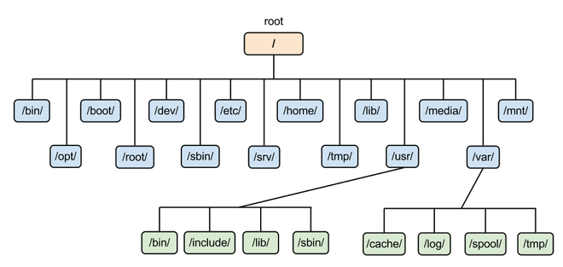
- mount a file system:
  - refers back to the early days of computing when a tape or removable disk pack would need to be physically mounted on an appropriate drive device;
  - after being physically placed on the drive, the filesystem on the disk pack would be logically mounted by the operating system to make the contents available for access by the OS, application programs and users
- mounting point, mount/umount commands

4. AN OVERVIEW OF DIRECTORY TREE
4.1. Background
https://tldp.org/LDP/sag/html/fs-background.html
4.2. The root filesystem
https://tldp.org/LDP/sag/html/root-fs.html
4.3. The /etc directory
https://tldp.org/LDP/sag/html/etc-fs.html
4.4. The /dev directory
https://tldp.org/LDP/sag/html/dev-fs.html
4.5. The /usr filesystem
https://tldp.org/LDP/sag/html/usr-fs.html
4.6. The /var filesystem
https://tldp.org/LDP/sag/html/var-fs.html
4.6. The /proc filesystem
https://tldp.org/LDP/sag/html/proc-fs.html

REFERENCES:
- Storing and organizing data files on disks
http://ntfs.com/hard-disk-basics.htm
http://www.mathcs.emory.edu/~cheung/Courses/377/Syllabus/1-files/intro-disk.html
- Anatomy of Linux journaling file systems
https://www.ibm.com/developerworks/library/l-journaling-filesystems/index.html
- An introduction to Linux filesystems
https://opensource.com/life/16/10/introduction-linux-filesystems
- Linux Filesystem Hierarchy Standard (FHS)
http://www.pathname.com/fhs/
- How to Mount and Unmount File Systems in Linux
https://linuxize.com/post/how-to-mount-and-unmount-file-systems-in-linux/
- ZFS (Zettabyte File System)
https://arstechnica.com/information-technology/2020/05/zfs-101-understanding-zfs-storage-and-performance/

